# Project: Product Shop

Product Shop is a system that registers users, categories, products and orders. It is a significantly big project, and as such it will have several parts. In this exercise you will land the basics of the application, in other words - the user functionality.

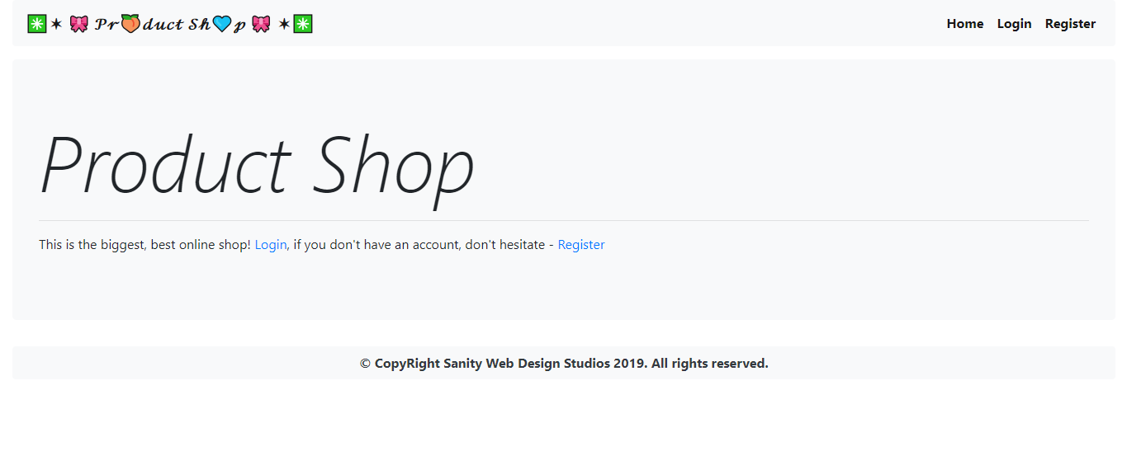

# Workshop: Part 4 – Testing

## Service Testing

You have been tasked to perform Unit testing on the **Service Layer** of the Product Shop application. Test all methods with all possible cases you can think of.

Use the **Code Coverage runner** of IntelliJ or a tool like [EclEmma](https://www.eclemma.org/) for Eclipse in order to calculate the coverage of your unit tests. Try to achieve a **Code Coverage** of **80%** on the **Services**.

## Integration Testing

You have been tasked to perform Integration testing on the **Web Layer** of the Product Shop application. Test all methods with all possible cases you can think of.